1 a. What are the two main classifications of data centers?
Data centers are mainly classified into two types.
- Service-oriented: Provide online services (e.g., Google, Facebook, Yahoo).
- Resource-oriented: Provide computing resources (e.g., Amazon EC2, Microsoft Azure).
b. List the classification of Data Centers (Tier1-4) and its features.
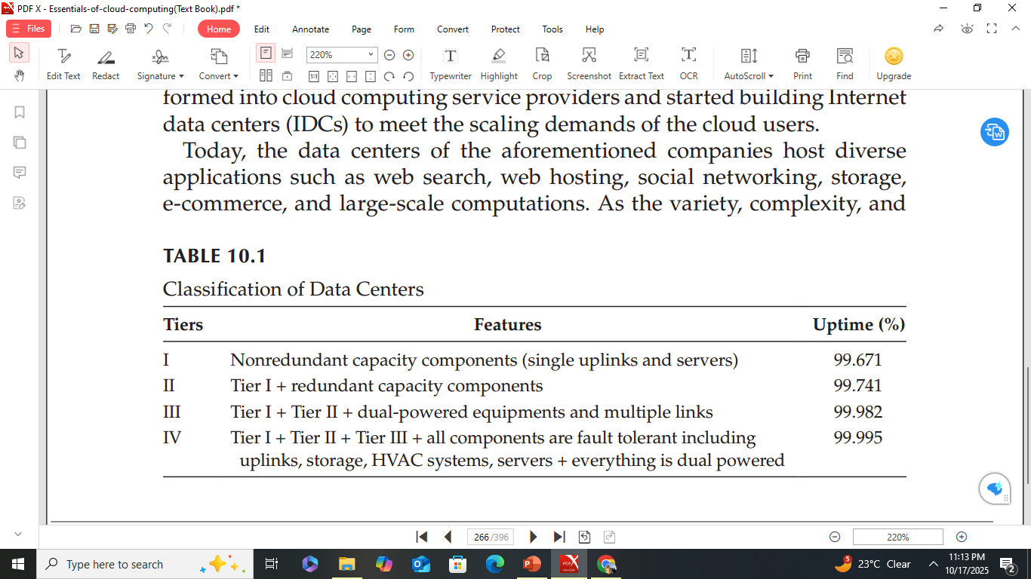
c. Explain the major transport layer issues and TCP Impairments in DCNs.
Transport Layer Issues in DCNs
Dominance of TCP
- TCP (Transmission Control Protocol) is one of the most widely used transport protocols on the Internet.
- It handles a large variety of Internet applications and forms most of the traffic in both types of Data Center Networks (DCNs).
- It has been the workhorse of the Internet since its inception.
Role and Success of TCP
- The success of the Internet is partly due to the congestion control mechanisms built into TCP.
- As the Internet’s scale and usage have grown exponentially, TCP has evolved to remain scalable and robust.
Limitations of TCP in DCNs
- Despite its strengths, state-of-the-art TCP fails to meet the three key DCN performance requirements.
These issues arise due to several impairments, including:
  - TCP Incast
  - TCP Outcast
  - Queue buildup
  - Buffer pressure
  - Pseudocongestion effect

TCP Impairments in DCNs
Evolution of TCP
- TCP has evolved over the past three decades to adapt to changing network conditions.
Challenges in Modern Networks
- The diversity of current and next-generation network characteristics and varied application requirements have created new challenges for TCP’s congestion control mechanisms.
TCP Incast
- TCP incast is a pathological behavior of TCP that leads to underutilization of link capacity in many-to-one communication patterns.
- Common in partition/aggregate applications such as web search, MapReduce, social networks, and advertisement selection.
Occurrence in Data Centers
- TCP incast is widely present in distributed storage systems, data-intensive scalable computing, and partition/aggregate workflows.
Many-to-One Communication Pattern
- An aggregator sends requests to multiple worker nodes.
- All worker nodes reply simultaneously, causing data to converge on a bottleneck link.
- This leads to buffer overflow at top-of-the-rack (ToR) switches, resulting in packet loss — a phenomenon called synchronized mice collision.
Barrier Synchronized Transmission
- Worker nodes cannot send the next data block until all finish sending the current block — known as barrier synchronized transmission.
Impact on Performance
- As the number of worker nodes increases, application throughput decreases due to packet losses.
- Retransmissions occur only after a retransmit timeout (RTO), typically a few milliseconds, harming mice traffic, which requires short response times.
- Fast retransmit mechanisms are ineffective for mice traffic because of the small number of packets and insufficient duplicate acknowledgements (dupacks).
Mitigation of TCP Incast
- Solutions exist at multiple layers — application, transport, and link layers.
- Some approaches propose modifying TCP, others replacing it, and some use non-transport layer techniques.
Barrier Synchronized Transmission
- Worker nodes cannot send the next data block until all finish sending the current block — known as barrier synchronized transmission.
Impact on Performance
- As the number of worker nodes increases, application throughput decreases due to packet losses.
- Retransmissions occur only after a retransmit timeout (RTO), typically a few milliseconds, harming mice traffic, which requires short response times.
- Fast retransmit mechanisms are ineffective for mice traffic because of the small number of packets and insufficient duplicate acknowledgements (dupacks).
Mitigation of TCP Incast
- Solutions exist at multiple layers — application, transport, and link layers.
- Some approaches propose modifying TCP, others replacing it, and some use non-transport layer techniques.
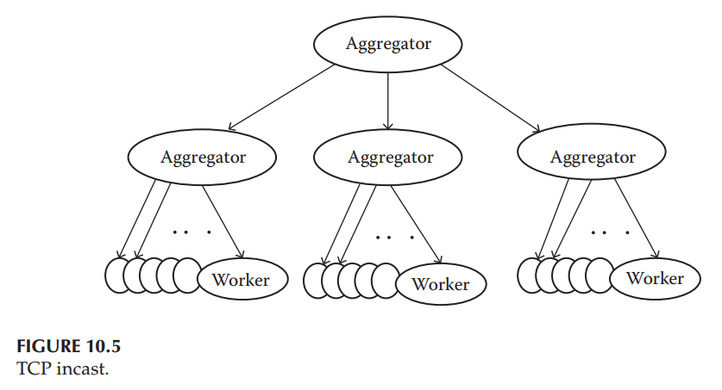
TCP Outcast
- TCP Outcast occurs when a small set of flows and a large set of flows arriving at different input ports of a switch compete for the same bottleneck output port.
- The small set of flows suffers a significant drop in throughput.
Cause of TCP Outcast
- Mainly occurs in data center switches that use drop-tail queues.
- Drop-tail queues cause consecutive packet drops from one port, leading to frequent TCP timeouts — this effect is known as port blackout.
Impact of Port Blackout
- Frequent timeouts increase latency and degrade response times for small flows.
- Example: In a switch where ports A and B compete for output port C, packets from one port (e.g., A) are dropped consecutively, while packets from the other (B) are successfully queued.
RTT Bias and Inverse RTT Bias
- Normally, TCP throughput is inversely proportional to the Round-Trip Time (RTT) flows with lower RTT get higher bandwidth.
- In DCNs affected by TCP Outcast, the opposite happens: flows with low RTT are outcasted by those with high RTT — known as inverse RTT bias.
- Main Factors Causing TCP Outcast
(1) Use of drop-tail queues in switches.
(2) Many-to-one communication patterns, where multiple flows converge on a single output port.
- Both are common in data center networks (DCNs).
Mitigation of TCP Outcast
- Replace drop-tail queues with other queuing mechanisms such as:
  - Random Early Detection (RED)
  - Stochastic Fair Queue (SFQ)
- Alternatively, reduce buffer occupancy by designing efficient TCP congestion control laws at the end hosts.
- Example scenario of port blackout
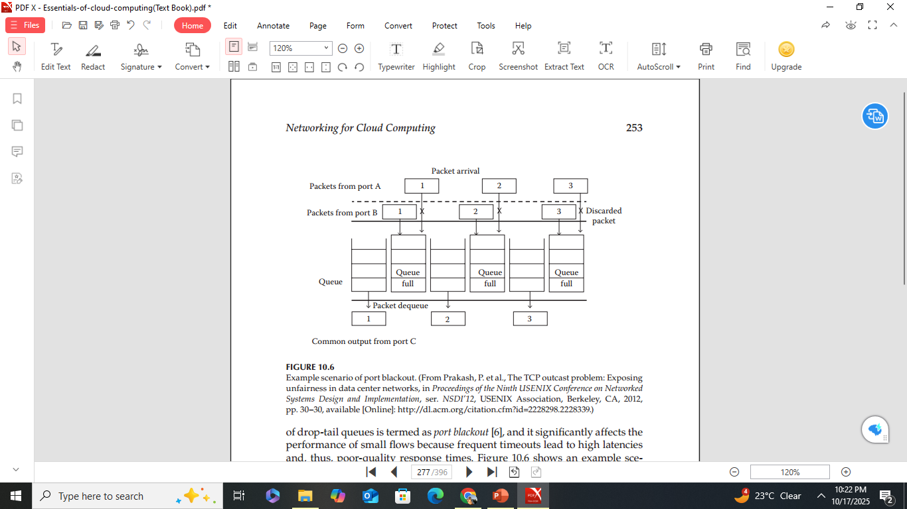
Queue Buildup
- In Data Center Networks (DCNs), mice traffic, cat traffic, and elephant traffic coexist.
- The long-lasting and greedy nature of elephant traffic can cause extreme congestion and buffer overflows at bottlenecks.
- When mice traffic and elephant traffic share the same route, the performance of mice traffic is severely impacted.
Effects on Mice Traffic
- The performance degradation of mice traffic occurs in two ways:
  - Packet Losses:
    - Elephant traffic occupies most of the buffer space.
    - Mice traffic packets are more likely to be dropped, leading to frequent timeouts similar to the TCP Incast problem.
  - Increased Queuing Delay:
    - Even without packet loss, mice traffic packets experience high latency as they wait behind elephant traffic packets.
    - This condition is known as queue buildup.
Mitigating Queue Buildup
- The problem can be mitigated by minimizing queue occupancy in DCN switches.
- Traditional TCP variants use a reactive approach to congestion control (reducing sending rate only after packet loss).
- A proactive congestion control approach is needed to minimize queue buildup and maintain performance.
Buffer Pressure
- Buffer pressure is caused by the long-lasting and greedy nature of elephant traffic.
- When mice traffic and elephant traffic share the same route, the elephant traffic occupies most of the buffer space.
Impact on Mice Traffic
- With limited buffer space available, bursts of mice traffic packets (common in many-to-one communication) cannot be accommodated.
- This leads to packet loss and poor performance of mice traffic.
- Since most DCN traffic is bursty, mice packets are frequently dropped because elephant flows persist longer and continue to occupy buffer space.
Mitigation of Buffer Pressure - Similar to queue buildup, the solution lies in minimizing buffer occupancy in switches.
Pseudo congestion Effect
Role of Virtualization
- Virtualization is a key technology enabling cloud computing by using Virtual Machines (VMs) to provide on-demand services and remote access.
- Data centers that use VMs are called virtualized data centers.
Advantages of Virtualization
- Provides efficient server utilization, service isolation, and lower system maintenance cost.
- However, it also impacts the performance of traditional protocols like TCP and UDP.
Performance Degradation
- Studies (e.g., Amazon EC2) show that virtualization causes unstable throughput and high end-to-end delay, even under low network load.
- The main cause is hypervisor scheduling latency — the delay each VM experiences while waiting for CPU access.
Hypervisor Scheduling Latency
- Increases as more VMs share the same physical machine.
- Can range from microseconds to several hundred milliseconds.
- Leads to unpredictable network delays (RTT), unstable throughput, and longer end-to-end delay.
- High latency may trigger Retransmission Timeout (RTO) at the VM sender.
Definition of Pseudo congestion
- When RTO occurs due to hypervisor latency, the VM sender mistakenly assumes network congestion and reduces the sending rate.
- This false detection is called the pseudo congestion effect, since the congestion is not real but caused by virtualization delays.
Mitigation of Pseudo congestion
- Two main approaches to address the issue:
  - Design efficient hypervisor schedulers to minimize scheduling latency.
  - Modify TCP to intelligently detect pseudo congestion and react appropriately.
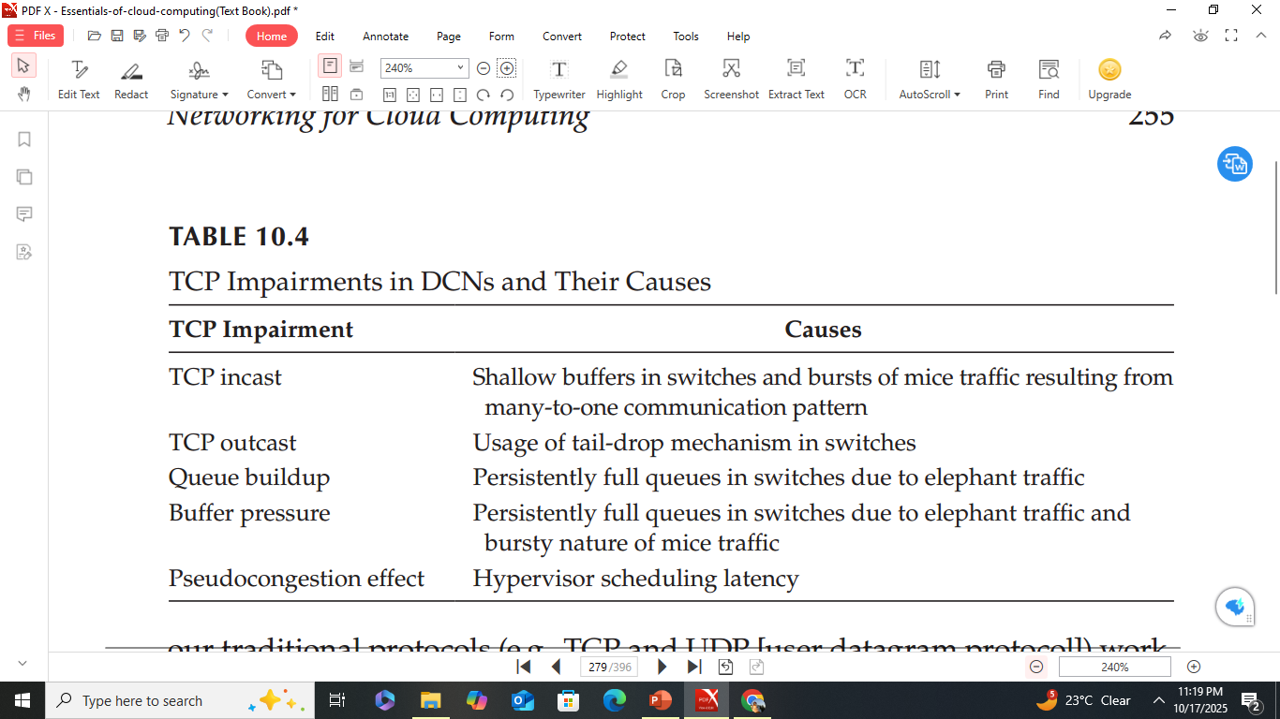
2 a. What are the three tiers of servers in the multitier data center model?
The three tiers of servers in the multitier data center model are
1. Web server
2. Application
3. Database
b. Why are servers placed in single rows forming corridors (aisles)?
Servers are placed in single rows forming corridors (aisles) to ensure proper airflow and cooling efficiency separating hot air exhaust from cold air intake (hot aisle - cold aisle design) to prevent overheating.
c. Explain the services provided by Google Cloud Platform with examples.
Google
- Google is one among the leading cloud providers.
- It offers secure storage of user’s data.
- Provides cloud platform, app engine, cloud print, cloud connect, and many more features.
- These services are scalable, reliable, and secure.
- Many of the services are offered free or at a minimum cost.
- This makes Google’s cloud services user-friendly.

Google Cloud Platform
- Google Cloud Platform enables developers to build, test, and deploy applications on Google’s highly scalable and reliable infrastructure.
- Google has one of the largest and most advanced networks across the globe.
- MapReduce, BigTable, and Dremel are the software infrastructures that serve as innovations for industrial development.
- It includes virtual machines, block storage, NoSQL datastore, and big data analytics.
- Provides a range of storage services for easy maintenance and quick access to user data.
- Offers both a fully managed platform and flexible virtual machines, allowing users to choose based on their needs.
- Allows easy integration of user applications within the platform.
- Applications can automatically scale up during heavy workloads and scale down when traffic reduces.
- The platform is designed to scale like Google’s own products, even during traffic spikes.
- Managed services such as App Engine and Cloud Datastore provide autoscaling for growing applications.
- Users pay only for what they use.
Google Cloud Storage
- Google Cloud Storage is a RESTful online file storage web service for storing and accessing data on Google’s infrastructure.
- Representational State Transfer (REST) is an architectural style with coordinated constraints applied to components, connectors, and data elements in a distributed system.
- The service combines performance, scalability, advanced security, and sharing capabilities of Google’s cloud.
- Data is safe and secure through redundant storage at multiple physical locations.
Tools for Google Cloud Storage
- Google Developers Console – a web application for performing simple storage management tasks.
- gsutil – a Python application that allows users to access Google Cloud Storage from the command line.
Google Cloud Connect
- Google Cloud Connect integrates Google Cloud with the API for Microsoft Office.
- After installing a plug-in for Microsoft Office, users can save files directly to the cloud.
- The cloud copy becomes the master document that everyone uses.
- Each file is assigned a unique URL that can be shared for viewing.
- Changes made to a document are visible to everyone viewing it.
- When multiple users edit the same section, Cloud Connect allows the user to choose which changes to keep.
- Upon upload, the service inserts metadata into the file to track changes across all copies.
- The backend is similar to the Google File System and uses the Google Docs infrastructure.
- Metadata guides updates to ensure changes sync correctly across all copies.
Google Cloud Print
- Google Cloud Print extends the printer’s function to any device connected to the Internet.
- Requires a free Google profile, an app, program, or website with the Cloud Print feature, and a cloud-ready printer or a printer connected to an Internet-enabled computer.
- Print requests go through Google servers, which route them to the appropriate printer linked to the user’s Google account.
- The printer must have power, Internet connection, paper, and ink to execute the print job.
- The printer can be shared with other people to receive documents via Google Cloud Print.
- Since most printers are not cloud ready, a computer acts as a liaison using a connector.
- The connector (a small code piece) interfaces between the printer and the Internet using the computer’s printer software.
- Cloud-ready printers can connect directly to the Internet and must be registered with Google Cloud Print.
- Developers can integrate Cloud Print into their apps or websites, but there is no standard method for executing print jobs.
- Limited functionality arises because not all apps or sites have Cloud Print integrated.
Google App Engine
- Google App Engine allows users to run web applications on Google’s infrastructure.
- Applications are easy to build, maintain, and scale as traffic and data needs grow.
- No servers to maintain — users simply upload the application, and it’s ready to serve.
- Apps can be served from a custom domain name or a free appspot.com domain.
- Applications can be shared publicly or restricted to organization members.
- Supports multiple programming languages and runtimes:
- Java runtime – uses JVM, Java servlets, and Java programming language.
- Python runtime – includes a fast Python interpreter and standard library.
- Go runtime – runs natively compiled Go code.
- These environments ensure apps run quickly, securely, and without interference from other apps.
- Pay-as-you-go model – users only pay for what they use.
- No setup or recurring fees; resources like storage and bandwidth are billed at competitive rates.
- Users can control resource limits to stay within budget.
Free tier includes:
- Up to 1 GB storage.
- Enough CPU and bandwidth for about five million page views per month.
- When billing is enabled, free limits increase, and charges apply only beyond free usage.
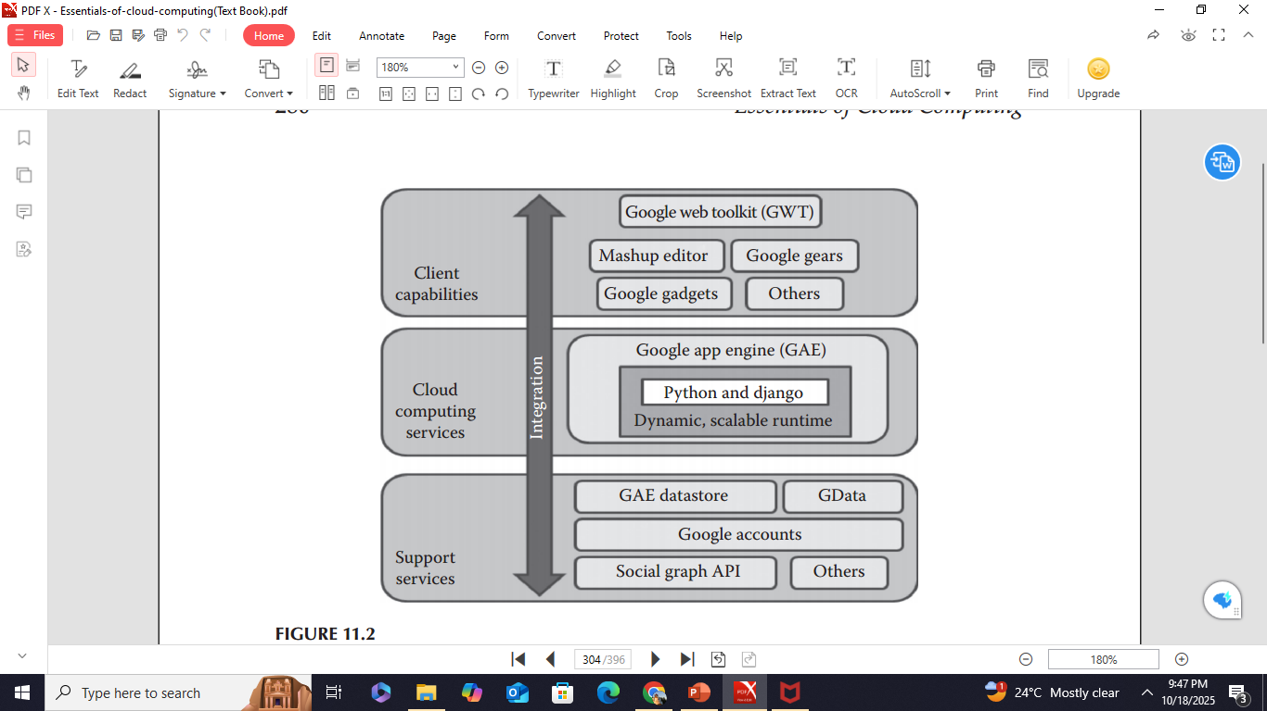
3 a. State one advantage and one disadvantage of a two-tier network topology.
Advantages of Two-Tier Design
- Simpler design (fewer switches, easier management)
- Reduced network latency (fewer hops)
Disadvantages of Two-Tier Design
- Limited scalability once aggregation switch ports are full.
- Adding more switches increases complexity.

b. What is pseudo congestion effect in virtualized DCNs.
Pseudo congestion effect in virtualized Data Center Networks (DCNs) occurs when multiple virtual machines (VMs) share the same physical network resources, causing virtual network congestion even though the physical network is not fully utilized.
c. List the tools/services provided by Microsoft and explain them in brief.
- Microsoft IT (MSIT) views cloud computing as a new approach to IT.
- Cloud computing is now the preferred and default environment for new and migrated applications at Microsoft.
- MSIT has developed a methodology and best practices to analyze existing application portfolios for migration to cloud computing.
- This analysis helps select the ideal cloud environment for each application.
- MSIT’s best practices have been documented and shared with Microsoft customers to help them migrate their organizations to cloud computing.
Windows Azure
- Windows Azure Cloud Services (PaaS) provide web and worker roles that let developers easily deploy and manage application services.
- The Windows Azure platform manages the underlying role instances and operating system, freeing developers from infrastructure management.
- The Migration Assessment Tool (MAT) helps assess readiness for application migration to Windows Azure.
- It asks a series of simple binary questions.
- Generates a report showing development effort needed and architecture considerations.
- The Windows Azure Pricing Calculator compares:
- The costs of current infrastructure vs.The potential operating costs on Windows Azure and SQL Azure.
- Windows Azure Pack for Windows Server includes Azure technologies available at no extra cost for installation in customer data centers.
- Runs on Windows Server 2012 R2 and System Center 2012 R2.
- Enables offering of a self-service, multitenant cloud consistent with the public Windows Azure experience.
Microsoft Assessment and Planning Toolkit
Microsoft Assessment and Planning Toolkit (MAP) is an agentless, automated, multiproduct planning and assessment tool for cloud migration.
- Provides detailed readiness assessment reports, executive proposals, and hardware/software information.
- Offers recommendations to help organizations accelerate application migration to private or public clouds.
- Analyzes server utilization data to support server virtualization and server consolidation using Hyper-V.
SharePoint
- Microsoft SharePoint is an online collaboration tool offered by Microsoft.
- It is a web application platform that includes a multipurpose set of web technologies supported by a common technical infrastructure.
- Has a Microsoft Office–like interface and is closely integrated with the Office suite.
- The web tools are designed to be usable by nontechnical users.
Functions and uses include:
  - Intranet portals, Document and file management
  - Collaboration and social networks
  - Extranets and websites, Enterprise search, Business intelligence
- Also supports system integration, process integration, and workflow automation.
- Unlike Google Cloud Connect, Microsoft SharePoint is not free.
- Offers additional features beyond what Google and other companies provide.
4 a. List the Major cloud service providers.
Major cloud service providers are:
Amazon Web Services (AWS), Microsoft Azure, Google Cloud Platform (GCP), IBM Cloud, and Oracle Cloud.
b. Describe the tools available for managing Google Cloud Storage.
- Google Developers Console – a web application for performing simple storage management tasks.
- gsutil – a Python application that allows users to access Google Cloud Storage from the command line.
c. Explain Networking issues in Data centers.
- Cloud networking is the fundamental backbone for providing cloud services.
- It has transformed how IT services are delivered to users.
- Several key issues arise in cloud networking, including availability, performance, and security.
Availability
- A major challenge for cloud providers is to maintain maximum uptime.
- Even a few seconds of downtime can cause loss of reputation and business impact.
- Downtime can also violate Service-Level Agreements (SLAs) between providers and users.
- The most common approach to achieve high availability is through data replication and regular backups.
Poor Network Performance
- The three key performance requirements of a Data Center Network (DCN) are: High burst tolerance, Low latency, High throughput.
- DCN traffic is a mix of mice, cat, and elephant traffic, each having different performance needs.
- The traditional TCP/IP protocol stack, designed for Internet scenarios, fails to perform optimally in DCNs.
Security
- Ensuring data security during transit and storage (at rest) remains a concern for cloud providers.
- Accidental data deletion (due to power outages or faulty backups) can cause serious loss to customers and hosting organizations.
- Providers must also ensure physical security of data center buildings and network infrastructure to prevent malicious insider attacks.
d. Explain the different types of traffic in DCNs along with their requirements.
Traffic in DCNs is classified mainly into three types
1. Mice traffic: The queries form the mice traffic (e.g., Google search and Facebook updates). Majority of the traffic in a DCN is query traffic, and its data transmission volume is usually less.
2. Cat traffic: The control state and coordination messages form the cat
traffic (e.g., small- and medium-sized file downloads)
3. Elephant traffic: The large updates form the elephant traffic (e.g., antivirus updates and movie downloads).
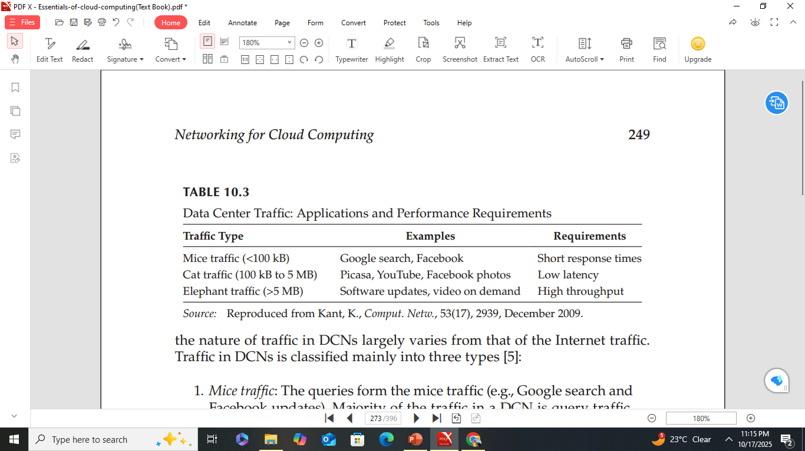
5 a. What is vCloud?
vCloud is a cloud computing platform by VMware that enables organizations to build and manage private, public, or hybrid clouds using virtualization technologies for flexible and scalable IT resource management.
b. Explain the features of Aneka.
Aneka is a cloud application platform developed by Manjrasoft that allows developers to build, deploy, and manage distributed applications in cloud environments.
Features of Aneka: flexible execution platform, multiple persistence options, multi-programming model support, custom tools, SLA/QoS management, and private -public cloud deployment.
c. Explain how cooling infrastructure is managed in modern data centers.

Cooling Infrastructure in Modern Data Centers
Modern data centers house thousands of servers that generate significant heat, requiring sophisticated cooling systems to maintain optimal operating temperatures and ensure energy efficiency.
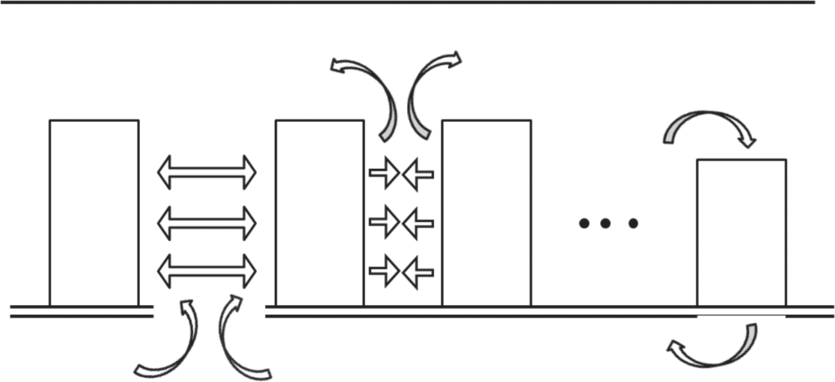
40°C
Airflow
Airflow

CRAC

Rack

Rack

Rack

1. Raised Floor and Aisle Arrangement
- Servers are placed on a raised plenum (floor) allowing cold air to circulate underneath.
- Server racks are arranged in alternating front-facing (cold aisles) and back-facing (hot aisles) rows.
- Cold air is pushed up through perforated tiles in the cold aisles, and server fans draw this air through the equipment.
- The hot air exiting from the back rises into the hot aisles and is directed to the chiller plant for cooling and recirculation.
- This design forms the hot aisle–cold aisle layout, improving airflow management and cooling efficiency.

2. Air Conditioning and Chiller Systems
- Building-level air-conditioning units and chiller plants cool the warm air collected from the hot aisles.
- Fans and ducts help in even distribution of cooled air.
- Deflectors or containment panels are used to prevent mixing of hot and cold air, reducing hot spots.

3. Advanced Cooling Innovations
- Recent designs include liquid cooling, immersion cooling, and rear-door heat exchangers for high-density racks.
- Free cooling techniques use outside air or evaporative cooling to reduce power consumption.
- Green data center designs use energy-efficient materials and renewable energy to minimize environmental impact.

4. Environmental and Design Factors
- Site selection considers climate, power availability, and disaster risk.
- Some companies like Google, Microsoft, and Yahoo build hyper scale facilities that integrate power and cooling innovations at massive scale.
- Data centers are now designed as modular, mobile, or hybrid structures that can optimize cooling and power efficiency dynamically.

5. Intelligent Monitoring and Management
- Modern DCs use sensors, AI, and automated control systems to monitor temperature, humidity, and energy usage.
- Dynamic resource allocation and real-time adjustments help maintain ideal cooling with minimal energy waste.
d. Explain in detail the four types of network accesses required in data centers.

Types of Network Accesses Required in Data Centers
Modern Data Centers (DCs) require multiple network types to handle communication between clients, servers, storage systems, and management components.
The four major types of network accesses are:

1. Client–Server Network
- Purpose: Provides external connectivity between the data center and end users or clients on the Internet.
- Technology Used: Traditional wired Ethernet or Wireless LAN (Wi-Fi).
- Function:
  - Clients send requests to applications hosted in the data center.
  - The responses are sent back over the same network.
- Example: A user accessing a web application or cloud service hosted in the data center.
- Requirement: High reliability, strong security, and stable Internet connectivity.

2. Server–Server Network
- Purpose: Enables high-speed communication among servers inside the data center.
- Technology Used: Ethernet, InfiniBand (IBA), or similar high-speed interconnects.
- Function:
  - Allows distributed servers to exchange data efficiently.
  - Supports load balancing and parallel processing for applications running on multiple servers.
- Requirement: Low latency, high throughput, and fault tolerance.
- Example: Communication between an application server and a database server within the same data center.

3. Server–Storage Network
- Purpose: Provides fast and reliable connectivity between servers and storage systems.
- Technology Used: Commonly Fibre Channel, though Ethernet and InfiniBand can also be used.
- Function:
  - Facilitates data storage, retrieval, and backup operations.
  - Ensures that data is always available to compute nodes.
- Requirement: High bandwidth, low latency, and high data integrity.
- Example: File transfers between storage arrays and application servers.

4. Management Network
- Purpose: Used to monitor, manage, and control data center infrastructure.
- Technology Used: Typically Ethernet, often with separate cabling from production networks.
- Function:
  - Handles administrative tasks such as configuration, updates, and health monitoring.
  - Isolates management traffic from regular data traffic for security and performance.
- Requirement: Secure access, reliability, and redundancy.
- Example: Network used for controlling switches, routers, and virtualization management tools.
6 a. Explain SAP HANA Cloud.
SAP HANA Cloud is a cloud-based in-memory database platform by SAP that provides real-time data storage, processing, and analytics for modern business applications.
b. Explain the services provided by IBM SmartCloud.
Services provided by IBM SmartCloud:
- Infrastructure as a Service (IaaS): Provides virtual servers, storage, and networking resources.
- Platform as a Service (PaaS): Offers tools and environments for developing and deploying applications.
- Software as a Service (SaaS): Delivers IBM software applications over the cloud.
- SmartCloud Managed Backup: Ensures secure data backup and recovery.
- SmartCloud Monitoring: Monitors system performance and resource usage.

c. What are the services offered by EMC IT? Explain.
EMC
- EMC needs dynamic scalability and infrastructure agility; choose cloud computing to reduce complexity and optimize infrastructure.
- Offering IT as a Service (ITaaS) reduces energy consumption via resource sharing.
EMC IT
- Virtualization is the core; enables on-demand resource allocation, boosting efficiency and utilization.
- EMC IT provides IaaS, PaaS, and SaaS.
Services
IaaS
- Lets business units provision network, storage, computing, operating systems—individually or as integrated services.
PaaS
- Supplies secure application/information frameworks atop app server, web server, database, unstructured content management, security.
- Database platforms: Oracle Database as a Service, SQL Server as a Service, Greenplum as a Service.
- Application platforms: application development, Enterprise Content Management as a Service, Information Cycle Management as a Service, Security PaaS, Integration as a Service.
SaaS
- Delivers applications and tools for business enablement.
- Unifies solutions under Business Intelligence as a Service; also offers ERP and CRM as a Service.
UIaaS
- Provisions the user/interface experience rather than the physical device.

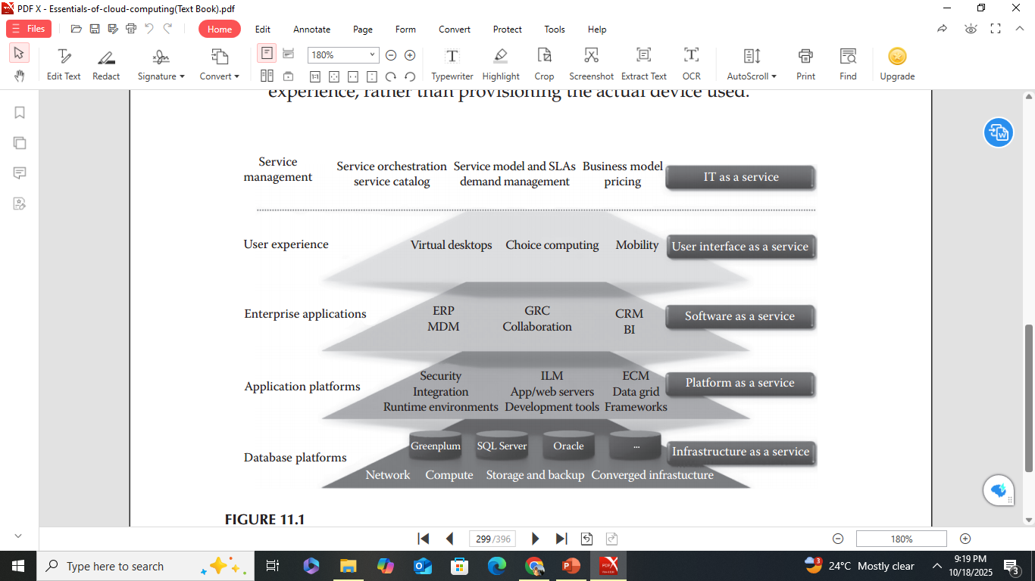
d. Explain in detail the architecture and modules of Captiva Cloud Toolkit with examples.
Captiva Cloud Toolkit
- Captiva Cloud Toolkit is an SDK (Software Development Kit) developed by EMC to help web application developers quickly add scanning and imaging functionalities to web-based business applications.
- Ideal for document capture vendors, software developers, and enterprises building custom, scan-enabled web apps.
Benefits
- Enables development of scan-enabled applications in as little as one week.
- Reduces development, testing, and support costs.
- Improves time-to-market and return on investment (ROI).
- Enhances competitiveness in the distributed document capture market.
Functionality
- Allows importing of images from fax, email, scanners, or repositories.
- Composed of multiple modules to manage scanning, processing, and exporting.
Key Modules
1. Scan
- Entry point to Captiva — imports documents from a scanner.
- Works at page level to bring images one by one.
- Supports PDF, TIFF, JPG, and other document types.
2. MDW (Multi Directory Watch)
- Another entry point to Captiva.
- Imports documents directly from a folder or repository (no scanner needed).
- Useful for soft copies, e.g., email attachments.
- Acts like a scan module but doesn’t interact with a scanner.
3. IE (Image Enhancement)
- Improves image quality for better processing.
- Performs tasks such as deskew, noise removal, etc.
- Can be configured according to business needs and image types.
4. Index
- Used for data capture, extracts key fields from documents.
- Example: For bank forms, fields like Account Number and Sort Code.
- Can include validation fields to prevent incorrect data entry.
5. Export
- Acts as the exit point of Captiva.
- Sends images and data to different repositories (file systems, databases, etc.).
- Data can be used by various business divisions.
6. Multi
- Final cleanup process in Captiva.
- Deletes batches after successful export.
- Can be configured to skip deletion if backups are required.

